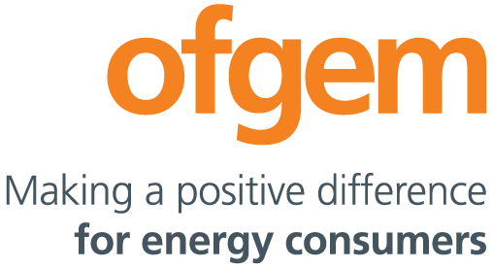

Michael Gibbons
Elexon
350 Euston Road
4th Floor
London
NW1 3AW

Direct Dial: 020 7901 7260
Email: neil.barnes@ofgem.gov.uk

Date: 09/03/20

Dear Michael

BSC Panel Discussion: P379

At its meeting on 13 February, the Panel considered the P379 Interim Assessment Report. I understand from Ofgem and Elexon colleagues that the Panel had a fulsome and broad discussion about the scope of the modification, the ‘complexity’ of the solution(s) and, whether, ultimately, there would be demand for the flexibilities the solution could enable. The Panel agreed that Ofgem’s perspective should be sought about how we intend to assess P379, and how we see it fitting in with industry’s strategic direction of travel.

Ofgem sees innovation as critical to delivering a better energy market for consumers, while driving towards the Government’s net zero carbon emissions goal. As set out in our Strategic Narrative and our recent Decarbonisation Action Plan, “we want to support innovation and experimentation, particularly in the retail market, to create low carbon products and services that will directly benefit consumers.” We’re not seeking to pre-empt what innovation may come forward and what will be successful, but rather enable a wide range of propositions where this seems reasonable and appropriate. This will, of course, involve judgement calls on the likely costs and benefits of innovation for consumers.

We remain fully supportive of Elexon’s work in exploring the potential of ‘meter splitting’ as one of a number of means of enabling greater competition and product diversity in the retail market. We can’t see a reason in principle why meter splitting shouldn’t be allowed. Nevertheless, as you will be aware, the Working Group has surfaced a number of key considerations that will affect the desirability and deliverability of these kind of arrangements. The Working Group process has been invaluable in identifying dependencies and consequences that reside in other codes, in licences and potentially in legislation, which will require fuller consideration.

While our collective awareness of these dependencies and consequences has grown, these haven’t yet been fully mapped, nor solutions investigated. We recognise that enabling meter-splitting in Elexon’s systems will necessitate supply licence changes to clarify roles and responsibilities where there are multiple suppliers sharing a meter point. Examples include what happens in relation to switching, supplier failure and data access considerations. We will also need to consider the consumer experience of having multiple suppliers, and how this manifests in a licensing regime that presumes a single bilateral relationship; we stand ready to progress such issues if a positive case can be made for the modification.

We agree with the Working Group’s conclusion that Elexon should undertake and consult on an Impact Assessment (IA) as part of the modification process; this will give industry and other interested parties the opportunity to provide feedback not just on the specifics of the proposal, but on broader implications (including interactions with reform programmes like MWHHS). We think this will give a fuller picture of the costs and benefits, which will be necessary for us in making a decision on any forthcoming proposal. Our teams are already in dialogue about how we can support Elexon in bolstering its IA to elicit fuller evidence, analysis and insight.

We welcome Elexon’s plans to host a workshop to test appetite for such functionality. It would be hugely beneficial to hear from existing industry parties and other players about what use cases this could support and what types of business models are likely to come forward, and how they could deliver value to industry and consumers. We’re also keen to hear views on whether the original Proposer’s decision to limit the solution to licensed (and not exempt) suppliers will affect its desirability.

While we haven’t yet undertaken detailed planning on how we would assess the proposal, it has become increasingly apparent that the implications of the modification are not limited to a specific issue and will have wide-ranging implications. It’s very likely, therefore, that in considering the final proposal we would, in accordance with our statutory duties, look to undertake our own IA.

Section 5A of the Utilities Act places a duty on the Authority to do an IA where it appears to us that the proposal is ‘important’ (within the meaning of Section 5A of the Act). Our IA Guidance provides criteria for determining importance; in this case, our initial view, which is echoed in the Second Interim Assessment Report to the Panel, is that the proposal will have significant impacts and costs for industry participants.

Elexon’s White Paper on ‘Enabling customers to buy power from multiple providers’ has undoubtedly had a profound impact within the traditional and non-traditional corners of the electricity sector, and has helped bring discussions about innovative use cases from the margins to the mainstream. We look forward to hearing what industry has to say about its appetite for the P379 solution, and the expected costs and benefits that would arise from its implementation.

I trust this is helpful to the Panel in its deliberations about P379’s next steps.

Yours sincerely

Neil Barnes
Deputy Director, Future Retail Markets

