Credit Assessment Price Consultation – January 2021
Target Audience | BSC Parties |  | Purpose of paper | For consultation
Date published | 18 January 2021 |  | Classification | Public
Deadline for responses | 26 January 2021 17:00

Summary | The Credit Assessment Price (CAP) is used in the Energy Indebtedness calculations to convert Credit Cover into an energy value. We are consulting on an increase of the CAP to £64/MWh from the last notified value of £62/MWh. A change to CAP can impact the amount of Credit Cover required by a BSC Party.  If all respondents and Credit Committee members are in agreement, the proposed value will be implemented on Wednesday 17 February 2021.  If at least one respondent or Credit Committee member requests it or disagrees with the proposed value, Elexon will arrange a Credit Committee meeting. The Credit Committee will determine if a change needs to be made to the value of the CAP, the trigger level and when any new value should be implemented.  BSC Parties are invited to respond to this consultation using the proforma available on the Consultations page of the Elexon website. Please return responses to Credit.Committee@elexon.co.uk by 17:00 on Tuesday 26 January 2021.
- Introduction
  - The Credit Assessment Price (CAP) is a parameter defined in Section M1.4 of the BSC as ‘the price it would be appropriate to use to determine the equivalent financial amount of BSC Parties’ Energy Indebtedness.’
  - A trigger event has occurred, meaning that the absolute difference between the CAP and the reference price is greater than the absolute of current trigger level of +/- £6/MWh. As a result, a consultation on a new CAP value has commenced. The consultation period will end at 17:00 on Tuesday 26 January 2021.
  - If required, the Credit Committee will meet shortly thereafter to determine if a new CAP value should apply.
  - If the Credit Committee does not meet, the proposed CAP value will be implemented on Wednesday 17 February 2021.
- The CAP Value and trigger level
  - A Credit Committee meeting was held on 6 January 2021, following the last review of the CAP in December 2020, as there were objections to the proposed CAP value issued in the December consultation. This Credit Committee determined that the value of CAP would increase from £56/MWh to £62/MWh. The trigger level of +/- £6/MWh remains unchanged.
  - In its 6 January 2021 meeting, the Credit Committee expressed their reluctance for a further increase in the CAP before implementing the CAP of £62/MWh on 27 January 2021. In particular, considering the trend of the forward market prices for the next months (5-day rolling average prices for March/April).

  - The following table shows the historical CAP values since December 2018:
Effective From | Effective To | Value (£/MWh) | Trigger level (£/MWh)
04/12/2018 | 05/03/2019 | 68 | 6
06/03/2019 | 02/04/2019 | 56 | 6
03/04/2019 | 15/07/2019 | 48 | 6
16/07/2019 | 08/10/2019 | 43 | 5
09/10/2019 | 20/01/2020 | 54 | 5
21/01/2020 | 11/02/2020 | 47 | 5
12/02/2020 | 10/03/2020 | 41 | 4
11/03/2020 | 15/04/2020 | 36 | 4
16/04/2020 | 22/07/2020 | 30 | 3
23/07/2020 | 09/09/2020 | 36 | 4
10/09/2020 | 06/10/2020 | 46 | 5
07/10/2020 | 26/01/2021 | 56 | 6
27/01/2021 | - | 62 | 6
- The CAP Review Process
  - On the first working day of each week, we compare the value of CAP to the Reference Price, which is derived from average monthly forward market prices currently provided by ICIS Heren. Where the absolute difference between the two values exceeds the trigger level, it is termed a ‘trigger event’.
  - Once a new CAP value is notified to the BSC Parties, the weekly trigger process is resumed on the first working day of the following week. The trigger process uses the newly notified CAP value for the comparison with the Reference Price. Following a trigger event, we issue a consultation proposing that the CAP is changed.
  - Following the consultation, if at least one industry or Credit Committee member requests it, the Credit Committee will meet to consider the responses and the latest data. If the Committee feels it is appropriate, it will approve a new CAP value. If all respondents and Credit Committee members agree with the proposed value no meeting will be held.
  - If a Credit Committee meeting is held, the Credit Committee will confirm the date from which a change to the CAP will take effect, if they approve a new CAP value. This date would not be less than 15 Working Days after BSC Parties receive notification of the change.

- Recent Pricing Data
  - The current Reference Price (based on a five day average of February and March 2021 forward prices) is £76.73/MWh. This has triggered a CAP review with the Reference Price breaching the current upper trigger level of £68/MWh (last notified CAP of £62/MWh +/- £6/MWh).
  - Graph 1 shows the Reference Price in comparison to the CAP value and the upper and lower limits of the trigger level. The area shaded in blue on this graph indicates previous periods where the value of CAP was under review.
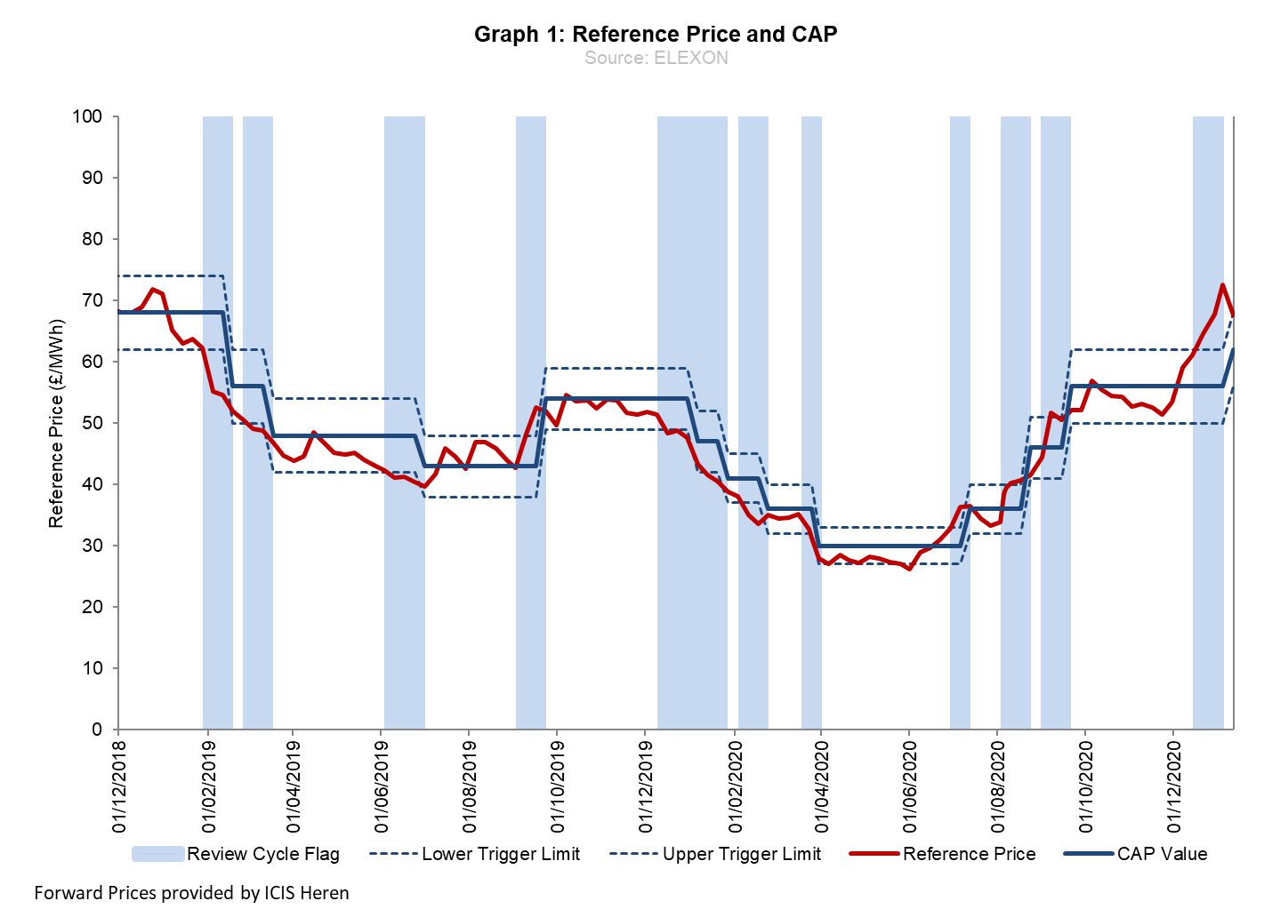

  - Graph 2 shows the daily average System Buy Price (SBP), the 30 day moving average of SBP and the value of CAP. This is a measure of how effective the current CAP review process is, as CAP is intended to be a proxy for outturn SBP.
  - Following the change to a single System Price and smaller Price Average Reference (PAR) volume, we have seen more volatile prices. This is an issue for a single CAP at a Settlement Period level. Looking at the 30 day moving average, the absolute difference was ~£2/MWh from the start of December 2020 to date. The January 2021 System Prices (up to 14th) have averaged around £93/MWh.

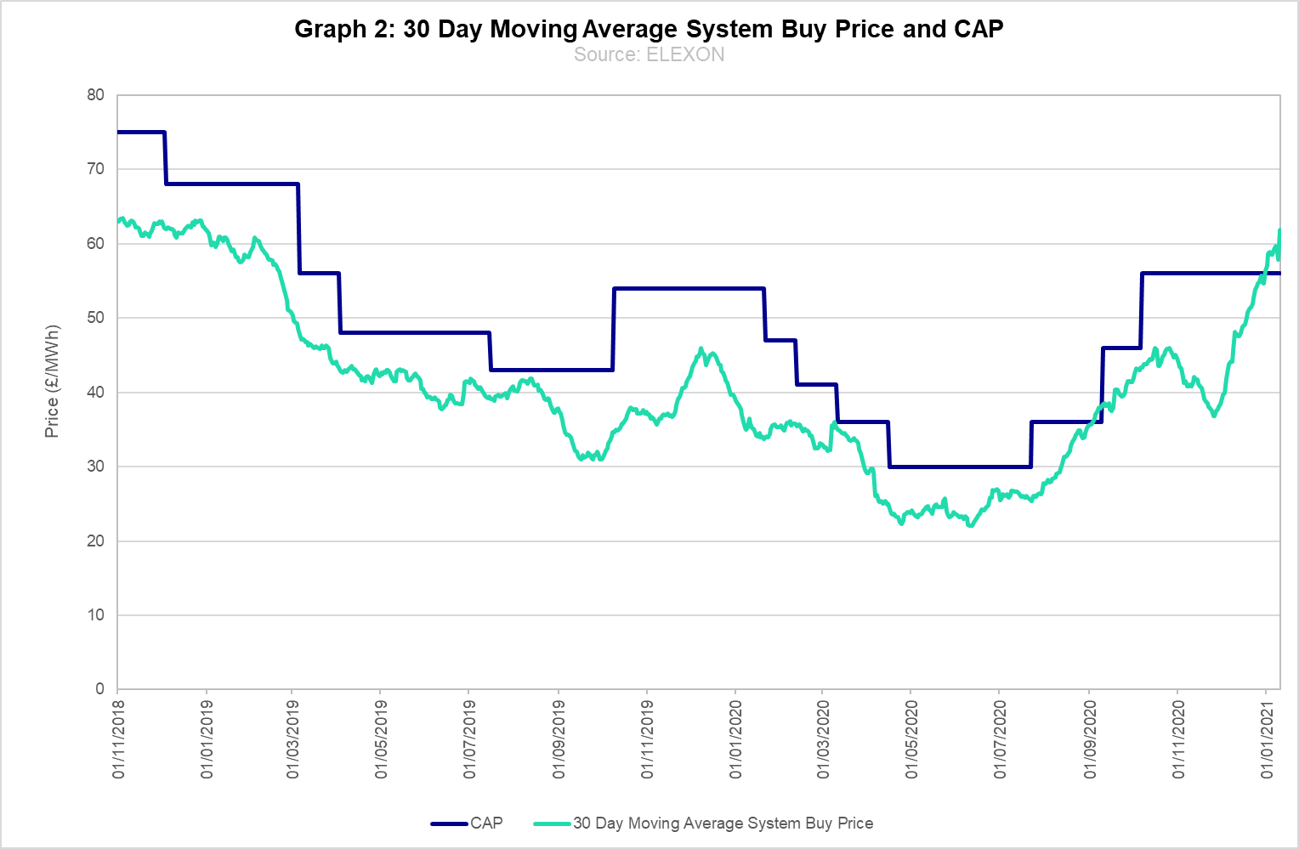

  - Interactive versions of Graphs 1 and 2 in this consultation are available to BSC Parties on the ‘Calculating new CAP values’ page of the Elexon website.
  - We invite Parties to consider the proposal to increase the value of CAP to £64/MWh, from the last notified CAP of £62/MWh, based on the current reference price and latest forward market prices.
  - The trigger level will remain unchanged at +/- £6/MWh.
  - Following the process described in the CAP Review process Guidance Note, Elexon issue a consultation for a new CAP value based on the implementation date for the new CAP. As a new CAP would potentially be implemented in February 2021, the consulted on value is based on a 5-day rolling average of March and April 2021 forward market prices (those which would be used in the Reference Price calculation in February 2021). The current 5-day rolling average of March and April 2021 forward market prices is £63.60/MWh.
- Next Steps
  - Following the end of the consultation period, if required, the Credit Committee will try to meet on the same week that the consultation closes, and decide whether to a change to the CAP is required. Any change will be notified to all BSC Parties, and the new value will come into effect at least 15 Working Days later.
  - If a Credit Committee meeting is not required at the end of the consultation period, the new CAP value of £64/MWh would be implemented on Wednesday 17 February 2021.
  - You are invited to respond to this consultation using the consultation proforma. Please return responses to Credit.Committee@elexon.co.uk by 17:00 on Tuesday 26 January 2021.

For more information, please contact:
Mehdi Jafari, Analyst
Credit.committee@elexon.co.uk
020 7380 4288

