|  |  |  |
| --- | --- | --- |
| PAB189/05a – Supplier Migration Plans | | |
| Meeting name | | Performance Assurance Board |
| Date of meeting | 27 October 2016 | |
| Paper number | | PAB189/05A |
| Owner/author | | Kathryn Gay |
| Purpose of paper | | Decision |
| Classification | | Public |
| Summary | | This paper summarises ELEXON’s recommendations to the Performance Assurance Board (PAB) following its review of the monthly Supplier Migration Plan Updates (SMUS), provided by Suppliers for P322 |

|  |  |  |  |  |
| --- | --- | --- | --- | --- |
|  |  |  |  |  |
| PAB189/05a |  |  | |  |
| Page 1 of 7 |  |  | © ELEXON 2016 |

1. Background
   1. As part of Modification P322 (Approved on 24 June 2015), Suppliers were required to submit Supplier Migration Plans (SMPs) by 31 August 2015, for approval by the PAB on 24 September 2015. Suppliers are also required to submit monthly updates; detailing progress against their approved SMP as they migrate Advanced Meters in Profile Classes (PC) 5-8 Half Hourly (HH) Settlement from 5 November 2015 to 1 April 2017. In addition, the plans need to be revised if Suppliers become aware that their approved SMP no longer reflect their expected migration pattern.
   2. This paper summarises ELEXON’s recommendations to the PAB concerning the monthly updates received from Suppliers, for August 2016 under their P322 obligations.
   3. Failure to submit a monthly update is deemed non-compliant, resulting in the application of the Error and Failure Resolution (EFR) technique.
   4. This paper provides:

* A summary of all the updates received (Appendix 1);
* A summary of the Settlement performance of sub 100kW Metered sites at industry level (Appendix 2);
* A summary of the P272 migration progression at industry level (Appendix 3)

1. SMUs
   1. All Suppliers produced their SMUs within defined time frames.
2. Migration process

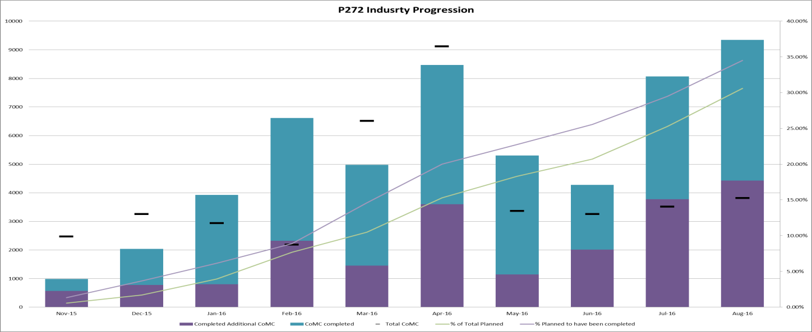

* 1. Following further amended SMUs this month, ELEXON reports that the industry is currently 3.92% behind planned migration volumes.

1. Update to the SMU reporting template
   1. Following discussions with both Ofgem and industry we have decided to amend the template for reporting. This amendment will see an additional column added to the SMU in which the Suppliers will be able to report the number of PC 5-8 AMR Metered sites that are reported to Ofgem as ‘advanced-capable’ in their regular information request about Supplier Licence Condition 12 compliance.
   2. Those Meters which are included in the new column should no longer be reported as an “opportunity”. Suppliers are reminded that if the addition of this column reduces the total volume of opportunities significantly then they are required to submit a new SMP.
   3. For the avoidance of doubt, once a meter becomes advanced, Suppliers need to migrate them to half-hourly settlement, in line with their P272 and P322 obligations.
2. Recommendations
   1. The PAB is invited to:

# NOTE the aggregate totals for the July 2016 reporting period (Appendix 1);

# NOTE the Settlement Performance for sub-100kW Metering Systems (Appendix 2); and

# NOTE the P272 Industry flight path (Appendix 3).

1. **AGREE** the changes to the SMU template (Appendix 4).

# Appendices

Appendix 1 – Totals for the July 2016 reporting period

Appendix 2 – Settlement Performance for sub-100kW Metering Systems

Appendix 3 – P272 Industry Flight Path

Appendix 4 – SMU Template (NEW)

For more information, please contact:

Kathryn Gay, Settlement Analyst

Kathryn.Gay@elexon.co.uk

020 7380 4300

Appendix 1 – Industry Totals



Appendix 2 – Sub 100kW Settlement Performance

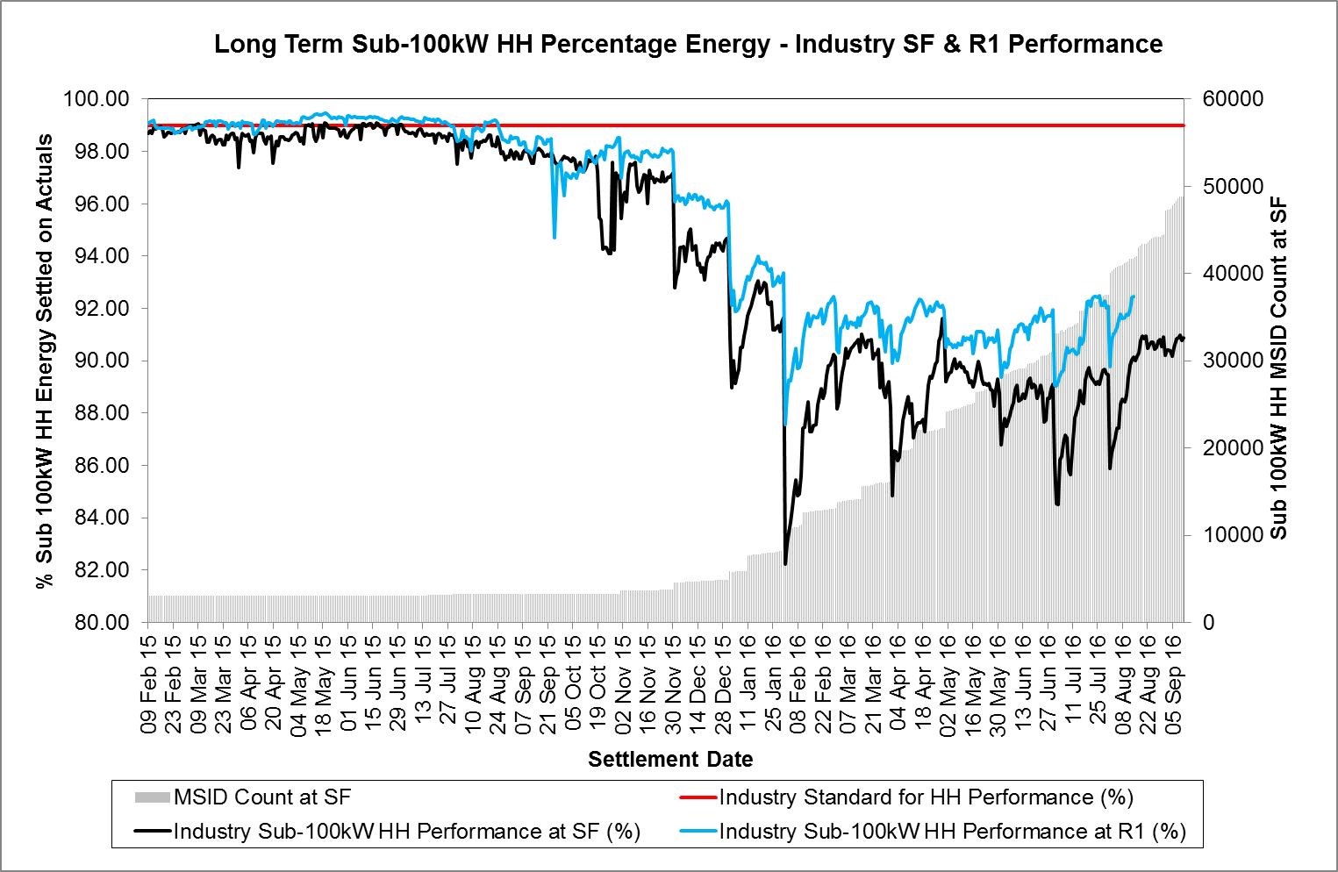

Appendix 3 – Industry Flight Path

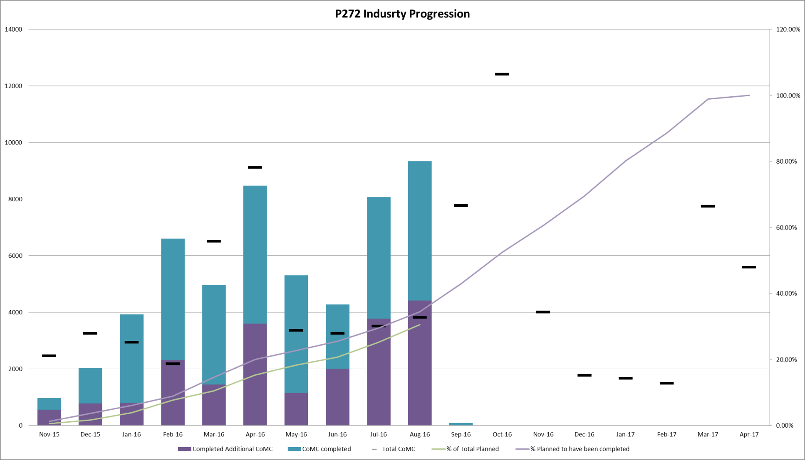

Appendix 4 – New SMU Template

